**CHAPTER ONE**

**INTRODUCTION**

**1.0 PREAMBLE**

This chapter discuss the background of the study, and also introduced the proposed topic, finally it also discusses the aim and objectives of the project and scope.

The online food ordering system is one of the latest services most fast food restaurants in the world are adopting. With this method, food is order online and deliver to the customer. This is made possible through the use of electronic payment system or cash payment at deliverance.

* 1. **BACKGROUND OF STUDY**

Business transaction are easily carried out online. Confectionery (Mac dee, Samosa, Masa, Spring rolls) businesses can take that step too due to the rapid growth of mobile and internet usage across Nigeria. An online ordering system will enable food vendors, restaurants and delivery person with an easy and flexible avenue for business in Nigeria. This method is easy for customers and food vendors to use the service by placing order online using the mobile app system, the system will enable customers to place order, the system will processed and inform the food vendors about the order placed on their product, the system also greatly lightens the load on the their end, as the entire process of taking and receiving orders is automated. Once an order is placed on the application that will be developed, it is placed into the database and then retrieved in real-time, by a web-based application on the restaurants end. Within this application, all items in the order are displayed, along with their corresponding options and delivery details, in a concise and easy to read manner. This allows the restaurant employees to quickly go through the orders as they are placed and produce the necessary items with minimal delay and confusion.

Due to the great increase in the awareness of internet and the technologies associated with it, several opportunities are coming up on the web. Many businesses and companies now venture into their business with ease because of the internet. One of such business that the internet introduced is an online food ordering system. In today’s age of fast food and take out, many restaurants have chosen to focus on quick preparation and speedy delivery of orders rather than offering a rich dining experience. Until recently, most of this delivery orders were placed over the phone, but there are many disadvantages to this system.

It is possible for anybody to order any goods via the internet and have the goods delivered to them.

Currently restaurants and food vendors in Kaduna Polytechnic are selling confectioneries at their food outlet in the process that customer must come to them for the purchase of items, sell and processed order from customers which result in multiple problems in delivering the intended services, such as mix-up in the orders placed by the customers as a result of high volume of orders that sometimes overwhelms food vendors, This especially commonly during peak periods and customers dissatisfaction as a of long queues at the selling terminals. This is further aggravated due to poor sitting arrangements at the selling points, collection and issuing of change.

The proposed system will solve the problems by automating the existing manual system of confectionery ordering, and also allow food vendor to register and satisfies the needs of the customer.

* 1. **MOTIVATION**

Due to the rapid increase in the population of Kaduna Polytechnic students, people are seeking more ways to purchase products with much ease and still maintain cost effective, The vendors need to showcase their products in order to sell to end users. The manual method of going to local food sales outlets to purchase food is becoming obsolete and more tasking. Food can be ordered through the internet and make payment without going to the restaurant or the food outlet.

* 1. **PURPOSE OF THE STUDY**

The main aim of this study is to design and implement a mobile application for food vendors that provide an avenue through the web where customers can login to the application and make a selection of the food they like and subsequently pay via e-banking or cash payment.

* 1. **METHODOLOGY**

To achieve the above objectives, the proposed system will be implemented using object oriented methodology.

1. Android (using Java Programming language) will be used to code the functionality of the mobile app.
2. Firebase real time database as the backend.
3. This project will be carried out using both primary and secondary method of data collection, Observation and Questioners will be used to collect data.
   1. **SCOPE OF STUDY**

This project is designed to allow customers to order confectioneries online within Kaduna polytechnic with minimal cost and in real time manner using android based application.

* 1. **EXPECTED CONTRIBUTION OF THE STUDY**

The study will help students and staff of Kaduna polytechnic and food vendors within the polytechnic with an easy and flexible method of transaction. Food vendors can advertise available foods in their food outlets.

1. Reduce the workload in the present system.
2. To keep accurate record of purchased order.

**Chapter two**

**Literature review**

**2.0 Preamble**

This chapter discusses the various opinions of some scholars and practitioners as regards to the development and implementation of online confectioneries ordering system, the chapter also discusses the history and some key elements that the system contains and makes use of such as payment gateways; finally the chapter shows the previous attempt or work related to the topic of study.

**2.1 REVIEW OF RELATED WORK**

The online confectionery ordering system provides convenience for the customers. This system increases the takeaway of confectionery than visitors. The online confectionery ordering app set up menu online and the customers easily places the order with a simple click. Also, with a confectionery menu online you can easily track the orders, maintain customer database and improve your confectionery delivery service. This system allows the user to select the desired confectionery items from the displayed menu. The user orders the confectionery items. The user’s details are maintained confidential because it maintains a separate account for each user. An id and password are provided for each user. Therefore, it provides a more secured ordering.

The mobile application era has thrown open a new pathway for today’s marketing. The mobile application has made all traditional modes of business outdated and generated amazing new possibilities in business. Mobile application is a combination of marketing acumen and technology – uses the Internet as a medium to advertise and sell services and goods. Today, more people are getting connected through mobile application and they are ready to trade through it. It also affects the operation of companies and organizations. Companies have changed their traditional business strategies into online marketing to suit customer needs and taste at any time (Jyotishman 2018).

In a modern generation Online confectionery ordering is a mobility of confectionery delivery or takeout from a local restaurant or confectionery cooperative. Now days the rapid growth in the use of internet and the technologies associated with it, the several opportunities are coming up on the web or mobile application. This is made possible through the use of electronic payment system. The payment can be done through the customer’s credit card, debit card. It is possible for everyone to order any goods from anywhere the internet and have the goods delivered at his/her home. All types of payment can be internet transaction ads to the economics of digital cash, the necessary tool for this process telecommunication with customers. The system will become an important tools use for restaurant to improve the management aspect by use of computer system to connect each and every confectionery ordering transaction instead of data record on it. In addition, it can also provide efficiency for the restaurant by reducing time consuming, minimize human errors or delivery and providing good quality and service to customers. In terms of the integrity and availability of the system provided, it can be concluded that this system is a suitable solution (T.Deepa et al. 2018).

The online confectionery ordering system sets up a confectionery menu online and customers can easily place the order as per they like. Also with a confectionery menu, online customers can easily track the orders. The management maintains customer database, and improve confectionery delivery service. The Restaurant management systems motivates us to develop the system. There are various facilities provided so that the users of the system will get service effectively. Also, the system considers Restaurants as well as Mess facility to the customers. Again, the idea comes that mostly mess users are person who are shifted for various reason in new cities. So, they are interrelated. Increasing use of smart phones is also considered as a motivation, so that any users of this system get all service on single click. Another motivation can be considered as the system will be designed to avoid users doing fatal errors, users can change their own profile, users can track their confectionery items through GPS, users can provide feedback and recommendations and can give ratings, it will give appropriate feedbacks to Restaurants / Mess service providers (Adithya R. et al 2017).

The recent development of the net has boosted the extension of on-line food services by facultative individuals to go looking, compare costs and handily access these services. on-line ordering has been a growing as a requirement have factor for the eating place business. on-line ordering has taken the food business by a storm. Technology puts a buried impact on the business industry, technology has changed the entire frame of restaurant industry, and it will continue doing a great job. A technically developed online food ordering system has changed the restaurant’s culture drastically and gives a new amazing comfort zone to the people across the globe (Mitali 2019)

The advancement in information and communication technology (ITC) has greatly influenced the business transactions. The adoption of wireless technology & emergence of mobile devices has led to automation in the hospitality industry. Business in hospitality industry such as restaurants can be improved with the combination of wireless and mobile technologies. The competition in restaurant business have increased with the advancements in confectionery ordering techniques (Shweta et al. 2013).

The earlier confectionery ordering system was entirely a manual process which involved waiters, pen and paper. The waiter had to note down orders from customers, take these orders to kitchen , update them in records and again make bill. Even though this system is simple it may involve human errors in noting down the orders. To overcome these limitations in manual system some systems were developed later like PDA based systems and multi-touchable restaurant management systems to automate confectionery ordering process (Priyanka R. 2013).

According to H. Sethu & Bhavya S.(2016), their aim was to investigate the students perception, behavior and satisfaction of online confectionery ordering and delivery services. Their study reveals that online confectionery purchasing services help the students in managing their time better. It is also found that ease of availability of their desired confectionery at any time and at the same time easy access to internet are the prime reasons for using the services.

According to Leong Wai Hong (2016), the technological advancement in many industries have changed the business model to grow. Efficient systems can help improve the productivity and profitability of a restaurant. The use of online confectionery delivery system is believed that it can lead the restaurants business grow from time to time and will help the restaurants to facilitate major business online.According to Varsha C. et al, (2015), the use of smart device based interface for customers to view, order and navigate has helped the restaurants in managing orders from customers immediately. The capabilities of wireless communication and smart phone technology in fulfilling and improving business management and service delivery. Their analysis states that this system is convenient, effective and easy to use, which is expected to improve the overall restaurant business in coming times.According to Hong Lan,(2016), online confectionery delivery market is immature yet; there are some obvious problems that can be seen from consumers‟ negative comments. In order to solve these problems, we can neither rely merely on the self-discipline of online confectionery delivery restaurants nor the supervision and management of online confectionery delivery platforms. Only by taking laws as the criterion, with the joined efforts of the online confectionery delivery platforms and restaurants, the government departments concerned, consumers and all parties in the society, can these problems be solved and a good online take away environment can be created.

**2.2 Factors that Encourages to optION for Online confectionery Delivery Service**

1. Ease & Convenience.
2. Cost Effectiveness
3. Easy Mode of Payment
4. Doorstep Delivery
5. Choice of Restaurants.

**2.3 CATEGORY OF CONFECTIONERY ORDERING SYSTEM**

1. **FULL SERVICE RESTAURANT**: Tradition confectionery order process used in most full-service restaurants starting when a waiter brought the guests the paper-based menu, and then waiting for the guests to choose items from the menu and inform the waiter the order items. The process typically required the guests to be seated in the restaurant and a waiter to assist the ordering .One of the most widely used confectionery ordering system is the conventional paper based system. In this system all records are stored on paper. The main drawback of this system is papers can get easily lost or damaged. There is also wastage of money, time and paper. Paper-based systems do not provide any form of dynamicity. Even a small change requires the re-print of entire menu-card. Also large amount of human efforts are required, this system is not work properly because it has some error and from a customer’s point of view it is time consuming. **b**. **SELF SERVICE RESTAURANT**: This process required the guests to place order at the service counter in the restaurant. The guests shall have decision in advance, before presented at the counter, of which menu items to order. Menu catalog is mostly presented as posters placing behind the order counter.

2.4  **AUTOMATED CONFECTIONERY ORDERING SYSTEM**

In order to reduce service cost and enhance customer experiences, few restaurants have invested in the service automation system. The automation system used to capture the confectionery order from guests ranged in many forms but mostly comprise of an electronic device with a screen presenting the menu and accept user’s input for order placing First waiter takes the order from customer. After taking the order, waiter should enter that order in system where PC was set up. At the kitchen information was displayed on screen. The kitchen staff would then prepare the dishes according to order and after completion of order they would inform to waiter, who collected and delivered the dishes to the respective tables. The system was also informing the waiter about the availability of a dish. If a certain dish was not available then waiter was able to ask for changes or even cancel a customer’s order. After serving the order, bill was generated at the cash counter as per customer order. The management had full authority to access all details of the customer which are fed into the system. With the improvement in the computer and communication technology, various systems were launched in market for the purpose of computerization of the confectionery ordering system. Some of the existing systems are mentioned below: **a) PERSONAL DIGITAL ASISTANTS (PDA'S) BASED SYSTEM**: A number of wireless systems like WOS, i-menu, FIWOS were developed when new technologies and approaches being introduced to automate the confectionery ordering process. All the above systems were PDA- based. The feature of PDA systems was that customers or waiters key in ordering process. Using wireless technology there was easy communication between the PDA’s and server. But PDA based system also had several drawbacks. PDA based system increased the restaurants expenditures. PDA systems also did not provide any real time feedback from customers. Menu cards in the PDA’s were not attractive and uninformative as it did not support images. **b) MULTITOUCH TECHNOLOGY**: Multi-touch technology is an advance version to the existing touch technology where user has authority to control and perform operations concurrently on the electronic visual displays using multiple fingers inputs. Large displays such as from the tabletop and the wall screen are deemed to be essentials for information visualization purposes when dealing with multiple users sharing the same display. It is reported that the social interaction is highly improved among users using a shared display and input. But there are certain limitations of the multi-touchable restaurant management systems. Touch screens available in the market are of capacitive, resistive types which are very costly. Limitations of capacitive touch screen are not able to operate with stylus until it is of conductive material. One more disadvantage of capacitive touch screen is it is expensive, offers less durability and short life. The drawbacks of resistive touch screen include its inability to support multi-touch gestures, its poor visibility in direct sunlight and its less durability. The technology can be susceptible to data-noise, it may be affected by large amounts of dirt and dust in the environment.

**2.5 Benefit of confectionery delivery appLICATION**

* 1. **EASY TO USE:** The confectionery ordering mobile apps are easy to use and offers high convenience with time and effort saving for the customers. This has encouraged more users to use the mobile apps and order their favourite online, to get them delivered to their houses. The UI/UX of these apps, along with the ease of navigability and efficient search options enhances the convenience of the confectionery ordering apps.b) **FLEXIBLE PAYMENTS:** The confectionery ordering mobile apps offer flexible payment options for the customers to be able to pay using various modes of payments, best suitable for them. The integration of various popular payment gateways offers flexibility and cashless transactions to the customers, thus encouraging them to use the confectionery delivery app.c) **REAL TIME TRACKING:** The confectionery ordering software is equipped with real time GPS tracking systems, such that the customers can track the delivery boy bringing their confectionery, along with helping the delivery boys to track down the exact address of the customers.d) **LOYALTY POINTS:** Online confectionery ordering often offer loyalty points to the customers for encouraging them to use the mobile app even more often. These loyalty points can be used by the customers to place future orders, thus helping them to use the app more often.

e) **EFFECTIVE CUSTOMER SUPPORT:** With 24/7 customer support facilities, the mobile apps can offer the best customer supports, answering to their queries and assisting them in any need or complaints. Customer support has effectively become even more efficient, since the customers can connect to the executives, with just a few clicks on their apps.

f) **EASE OF PAYMENT:** Any confectionery from anywhere the internet to and have the goods delivered at home. But the transfer method cash on payment or online payment. In other words possible to online pay digital cash. A customer will Payment can be amongst others either by credit card, more over the online payments benefit discount, coupon, gifts prize with the restaurant returning to attractive a customer.

**2.6 Disadvantage of online confectionery ordering system**

a) **COST OF INCREASE:** Online confectionery ordering system service know days increase your budget. Because of need a new delivery team to provide the services and you need to spend extra charges. In this system all type expense can be transfer on consumers.b) **Change of environment:** The main different between the online confectionery ordering and dining in a restaurant is the environment around us. If one person eats within home or he may not feel a change in environment and refreshment and relax. But comfort is really high level of online confectionery take away. If he dine-in luxury restaurant with super design and light music that environment gives better relax compared to the other.

**2.7 Need of the Study**

Due to large number of restaurants registered on confectionery-tech websites, consumers are confused and there is a huge ambiguity in the minds of customer regarding online confectionery ordering. If we consider demographic profiles most of the working class and teenagers prefer to order confectionery from mobile apps and websites. It is very important to have user friendly interface of websites and mobile apps with elucidating metadata and crystal and clear information. There are many factors which can affect loyalty of customers towards confectionery-tech companies. Some factors are delivery time, packaging, UI (User Interface) and UX (User experience) of mobile apps and websites, etc.

**CHAPTER THREE**

**METHODOLOGY AND DESIGN**

**3.0 PREAMBLE**

This chapter discusses the process of studying an already existing system, either computerized or manual and how the proposed system will be developed. It also entails the requirements of the new system.

**3.1 METHOD OF DATA COLLECTION**

Data collection is a way of gathering and analysing specific information to provide solution to questions and evaluate the results. It focuses on finding out all there is to a particular subject matter. Data is collected to be further subjected to analysis to explain a phenomenon. Collection of data provides range of outcomes for which the data is collected, but the key purpose for which data is collected is to put a researcher in advantage position to make predictions about future probabilities and trends. Observation and Interview are the methods adopted for the purpose of gathering information to achieve the proposed objectives.

**3.1.1 INTERVIEW**

Interviews provide in-depth information about a particular research issue or question. Because the information is not quantifiable (i.e., not amenable to statistical analysis), the interview often is described as a qualitative research method. Whereas quantitative research methods (e.g., the experiment) gather a small amount of information from many subjects, interviews gather a broad range of information from a few subjects.

**3.1.2 OBSERVATION**

Observation is time consuming but provides first-hand information about how activities are carried out and it can uncover much information on working practices. Observation is very helpful because people rarely give complete details on how they do things. Thus, after spending several years as a student, I was able to observe carefully the manual way of compiling results.

**3.2 SYSTEM MODELLING**

System modelling is a process of developing abstract of models of the new system, with each model presenting a different view of that system.

**3.2.1 USE CASE DIAGRAM**

A use case diagram is graphical representation description of the functionalities of a system and the interaction between the system and the user. The purpose of a use case diagram is to demonstrate different ways in which the user/administrator might interact with system.

**CHEF USE CASE**

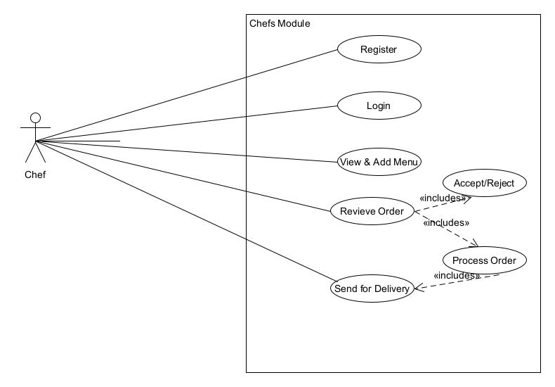

Fig.3.1 the chef use case

**THE CUSTOMER USE CASE**

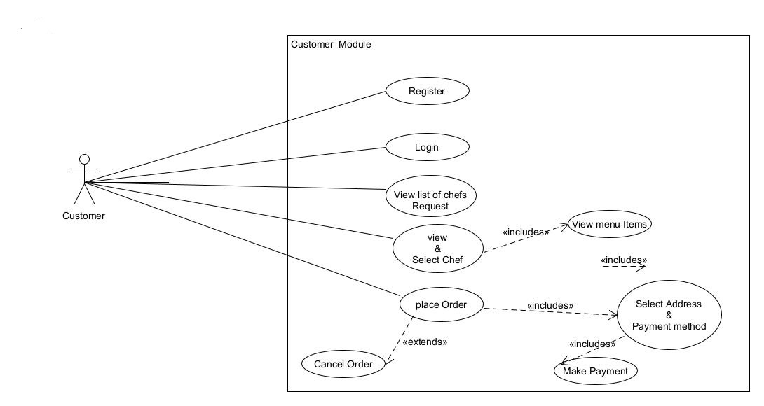

Fig.3.2 customer use case

**THE DELIVERY PERSON USE CASE**

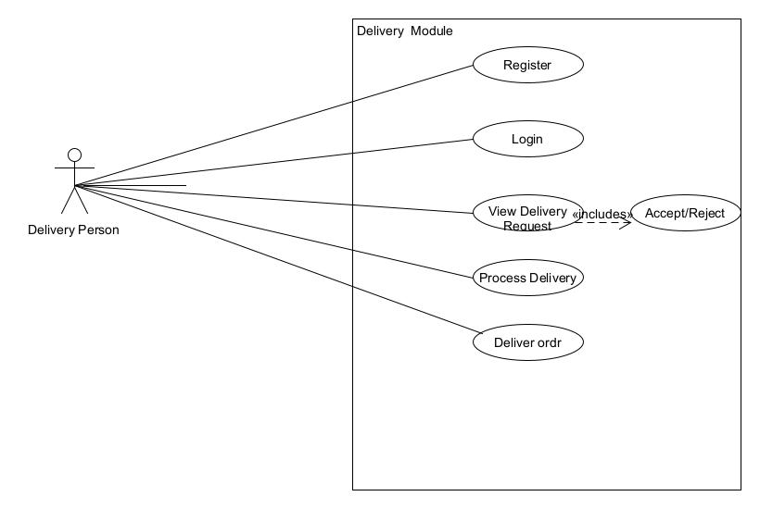

Fig.3.3 Delivery person use case

**3.2.2 CLASS DIAGRAM**

Class diagrams are visual representations of the static structure and composition of a particular system using the conventions set by the Unified Modeling Language (UML). Out of all the UML diagrams types, it is one of the most used ones. System designers use class diagrams as a way of simplifying how objects in a system interact with each other. Using class diagrams, it is easier to describe all the classes, packages, and interfaces that constitute a system and how these components are interrelated.

a) The top partition contains the name of the class and its attributes.

b) The left down contains the class chef and its attributes.

c) The right down contains the class delivery and its attributes.

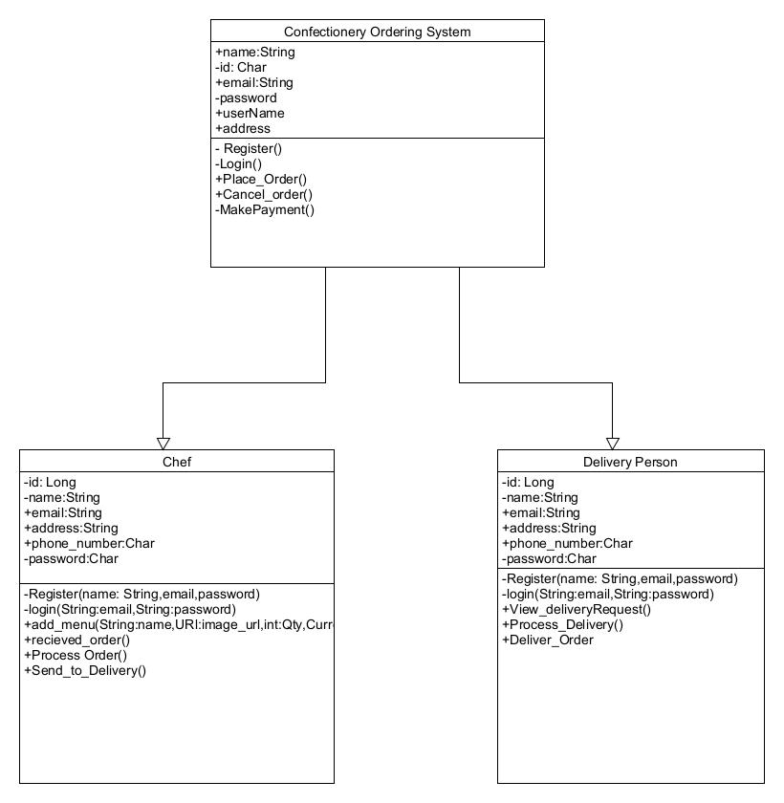

Fig.3.4 Class Diagram

**3.3 SYSTEM ACTIVITY DIAGRAM**

An activity diagram visually presents a series of actions or flow of control in a system similar to a flowchart or a data flow diagram. Activity diagrams are often used in business process modelling. They can also describe the steps in a use case diagram. Activities modeled can be sequential and concurrent.

**THE CHEF ACTIVITY** 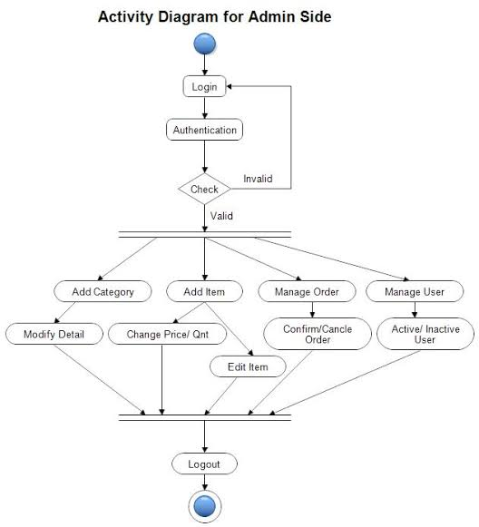

Fig.3.5 chef activity diagram

**THE CUSTOMER ACTIVITY**

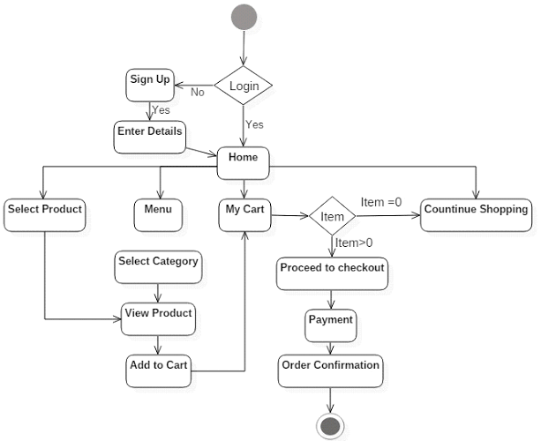

Fig.3.6 Customer activity diagram

**THE DELIVERY PERSON ACTIVITY**

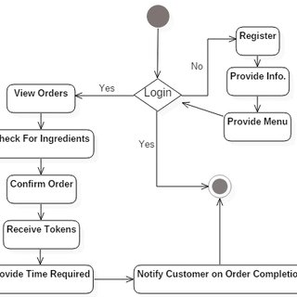

Fig.3.7 Delivery person activity diagram

**3.4 DATABASE DESIGN**

This project makes use of a real-time no SQL database that stores the app data in a form of tree structure the database. Firebase real-time database and fire Store were used to store and upload images used at runtime in the app by all the above mention Modules.

**3.5 OUTPUT DESIGN**

Output design is a drawing or specification or manufacturing instruction. Outputs design describe all the components, parts, and pieces that go into your system. The design of output is the most important task of any system. During output design, developers identify the type of outputs needed, and consider the necessary output controls and prototype report layouts.

**SCREEN SPLASH**

This is the first interface that splashes before the login page appears



Fig.3.8 Screen splash

**THE HOME PAGE**

Home page is the name of the main page of a website where visitors can find hyperlinks to other pages on the site.

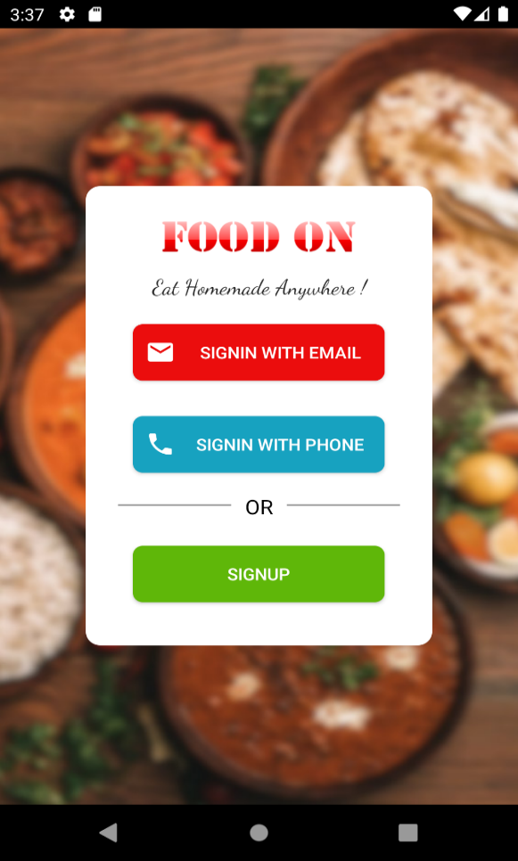

Fig.3.9 Home page

**CHEF LOGIN PAGE**

A login page is a web page or an entry page to a website that requires user identification and authentication, regularly performed by entering a username and password combination.

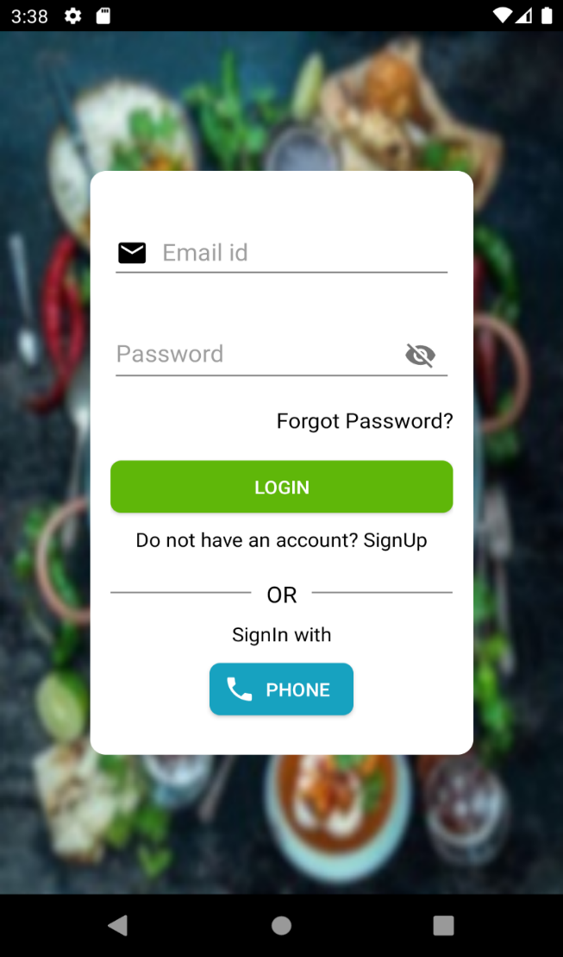

Fig.3.10 Login page

**3.6 SYSTEM REQUIREMENT**

System requirements are the configuration that a system must have in order for a hardware or software application to run smoothly and efficiently. Failure to meet these requirements can result in installation problems or performance problems.

**3.7 HARDWARE REQUIREMENT**

These requirements include the minimum processor speed, memory, and disk space required to install Windows and the following:

|  |  |
| --- | --- |
| **Hardware** | **Minimum Requirement** |
| **Disk Space** | **320 GB or more** |
| **Processor** | **1.4 GHz 64 bit+** |
| **Memory** | **4GB+** |
| **Display**  **Android Device(Phone)** | **(800 × 600) Capable video adapter and monitor**  **Android Version 5+** |

**3.8 SOFTWARE REQUIREMENT**

A software requirements specification (SRS) is a document that describes what the software will do and how it will be expected to perform. The following are the software specification:

**Android Studio Latest Version**

**Java JDK 8**

**Android Emulator**

**3.9 USER REQUIREMENT**

The user is expected to require an android phone that range range from version 5 and above for the installment .

**3.10 CHOICE OF PROGRAMMING LANGUAGE**

In programming, if you can write good software in Java, C#, Python, PHP, or any other languages then you can also write bad software using these languages. No single language is the best choice for any software. Some languages and frameworks are a better fit for projects than others. For this project we make use of the following framework and programming: Android Studio

Firebase Database

Java & Kotlin Programming

XML : Extensive Markup Language

**CHAPTER FOUR**

**SYSTEM IMPLEMENTATION EVALUATION**

**4.0 PREAMBLE**

This chapter discusses how the system is implemented and tested. Also shows how to implement the system using a step by step approach, a sample of the implemented system are also discuss with an image of each module to give a hint of how the user interfaces are design.

**4.1 SYSTEM TESTING AND EVALUATION**

 This is the process by which a system or components are compared against requirements and specifications through testing? The results are evaluated to assess progress of design, performance, supportability, etc.

**4.1.1 SYSTEM TESTING**

System testing involves the testing of the entire parts to determine that the functional requirement specification and the system requirement specification are met. Both the functional requirement specification and the system requirement specification describe the functionality that the system development and the users have agreed upon.

Testing involves exercising the program using data like real data processed by the program. You discover program defects or inadequacies by examining the out puts of the program and looking for anomalies. The goal of testing the software is to establish that the software is working according to its requirement expectation.

The following are the strategies adopted at the testing phase of the system;

1. **Unit Testing:** Unit testing is a procedure use to validate those individual units of source codes are working properly. A unit is a smallest part of an application that can be tested. In this application, the individual unit is the web page.
2. **Integration Testing:**  Is a systematic testing technique for constructing the software architecture while at the same time conducting test to unveil errors associating with interfacing. The reason for integration testing is to verify functional performance and reliability requirements placed on major design items. These groups of units are exercised through their interfaces. Using black box testing, success and error cases are being stimulated through appropriate parameter and data input. Simulated usage of shared data area and inter process communication is tested and individual subsystem are exercised via their input interface. Test cases are constructed to test that all components within assemblages interact correctly, across procedure calls of process activations. The unit tested components are integrated to build a program structure that has been ditched by design. The strategy adopted here is the incremental integration testing, a combination of top-down and bottom-up testing.

**4.2 SYSTEM CONVERSION PLAN**

It is a process of migrating from the old system to the new one. It provides understandable and structured approach to improve the communication between management and project team.

It includes the following activities −

1. Name all files for conversions.
2. Identifying the data requirements to develop new files during conversion.
3. Listing all the new documents and procedures that are required.
4. Identifying the controls to be used in each activity.
5. Identifying the responsibility of person for each activity.
6. Verifying conversion schedules.

**4.2.1 Parallel Conversion**

1. The process of transferring operations from one computer system to another, during which both systems are run together for a period of time to ensure that they are producing identical results.
2. Below are the advantages and disadvantages if the above selected method for this project:

**4.3 Database Installation**

To have this system well implemented a database most be created which store communicate with system data to have the system get to its objectives. The system used Firebase real-time database, which is a no SQL database that store data in a form of object tree instead of the normal SQL table, rows and column. Account need to be created with the google firebase platform for mobile application.

**4.4 SAMPLE OUTPUTS**

**SCREEN SPLASH**

This is the first interface that splashes before the login page appears



Fig.4.1 Screen splash

**THE HOME PAGE**

Home page is the name of the main page of a website where visitors can find hyperlinks to other pages on the site.

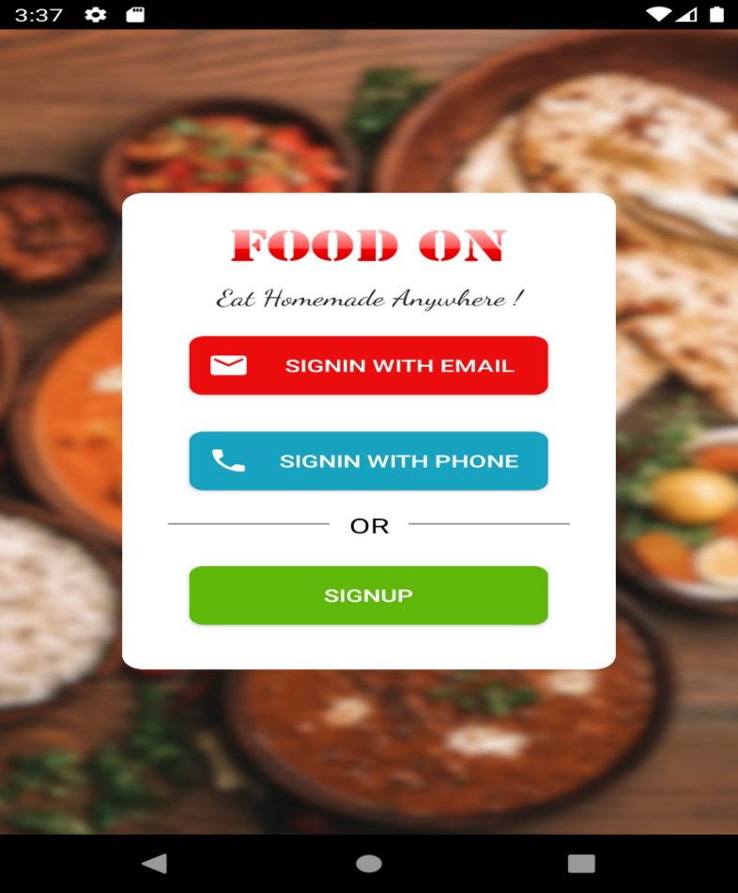

Fig.4.2 Home page

**CHEF LOGIN PAGE**

A login page is a web page or an entry page to a website that requires user identification and authentication, regularly performed by entering a username and password combination.

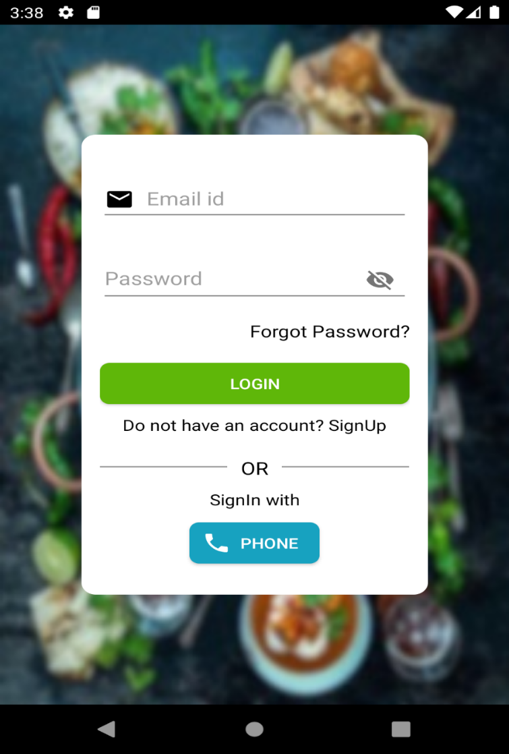

Fig.4.3 chef login page

**CHEF SIGNUP PAGE**

A signup page (also known as a registration page) enables users and organizations to independently register and gain access to your system. It is common to have multiple signup pages depending on the types of people and organizations you want to register.

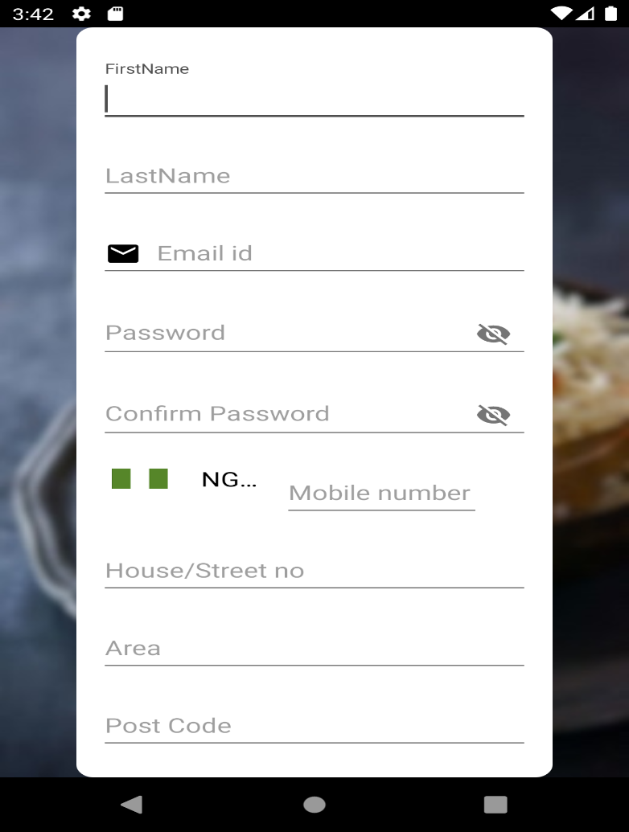

Fig.4.4 Signup page

**CHEF POST DISHES PAGE**

This interface allows the chef to post or delete the available confectionery at a given moment, and also to add the description of a given item.

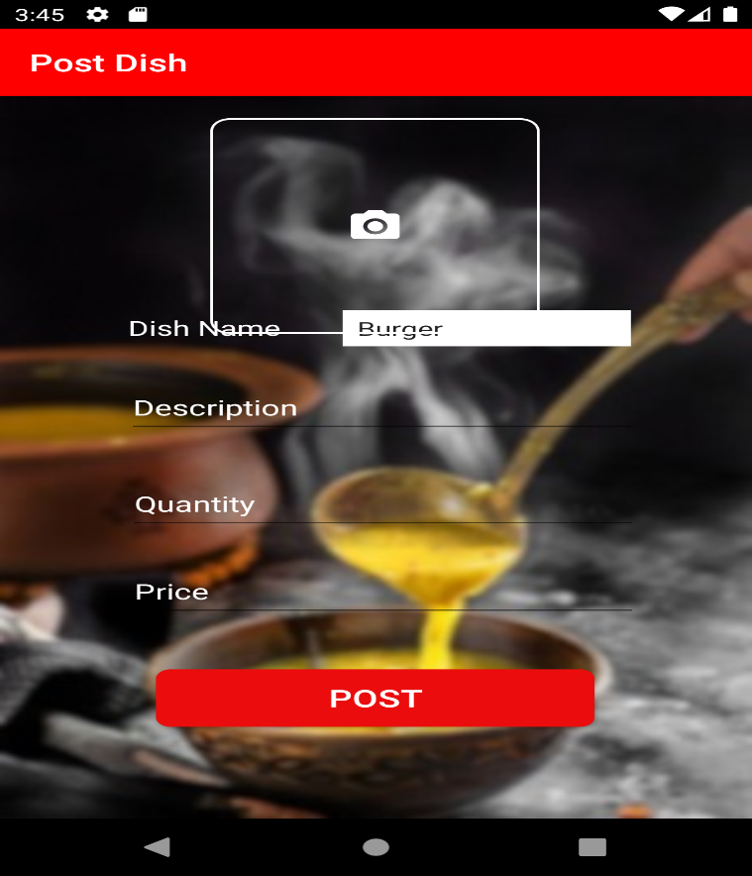

Fig.4.5 Post dishes page

**BOOKED ORDER**

This interface allows the chef to view on the booked order by a customer

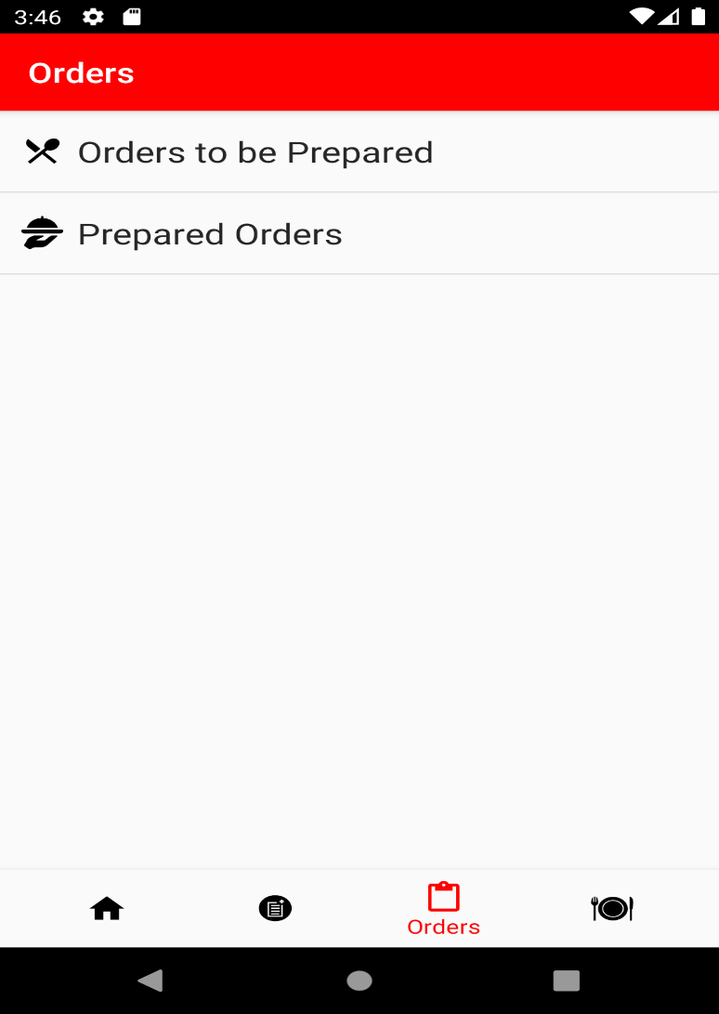

Fig.4.6 Booked order

**CUSTOMER ORDERING PAGE**

This interface allows the customer to view on available confectioneries and their prices

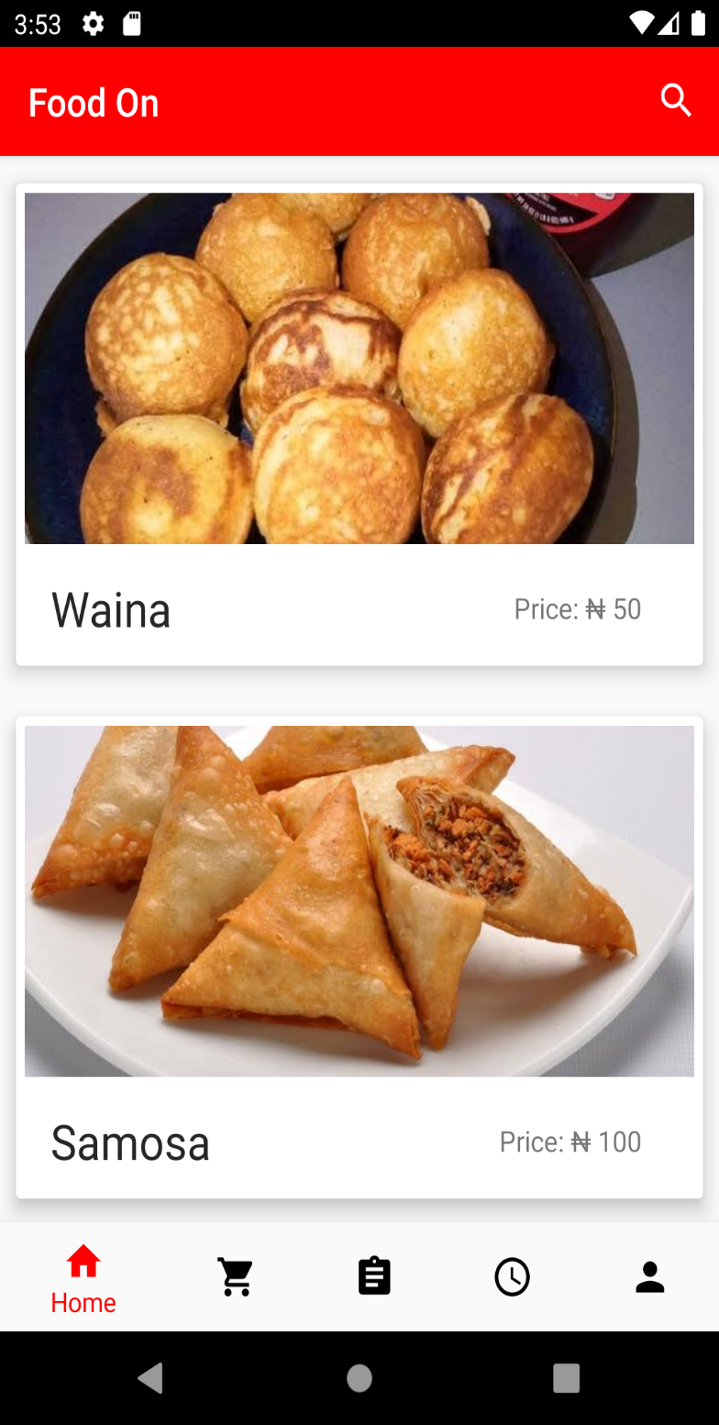

Fig.4.7 Ordering page

**PRODUCT DETAILS PAGE**

This interface allows the customer to view on the description of a certain item

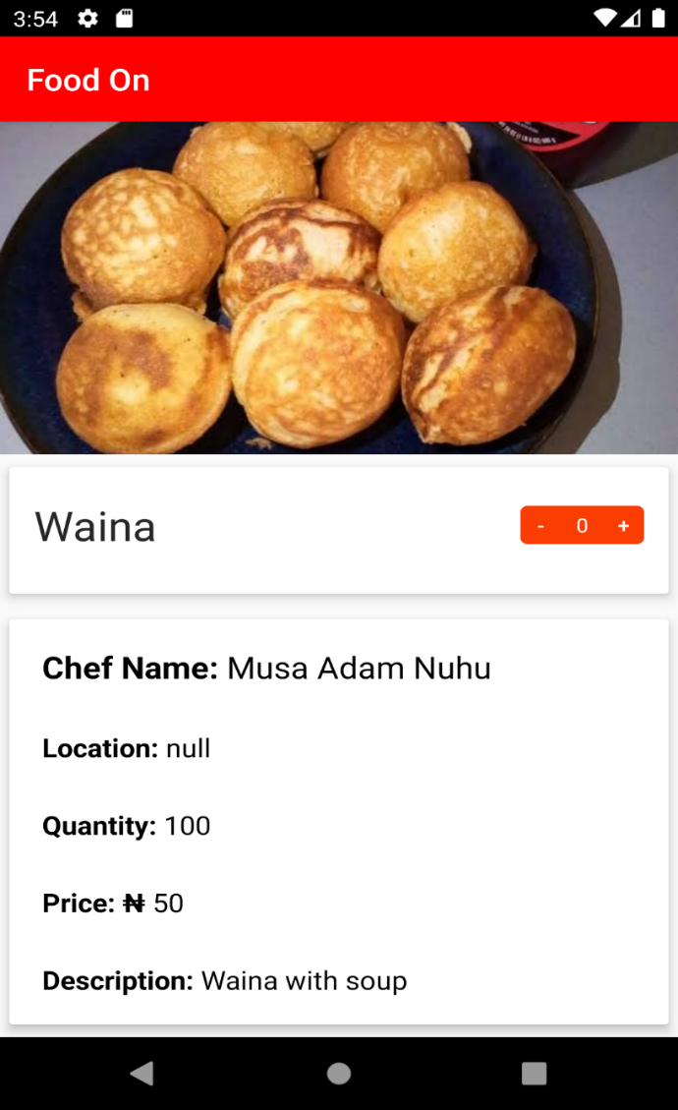

Fig.4.8 Product details

**CART**

This page allow the customer to view on the selected items

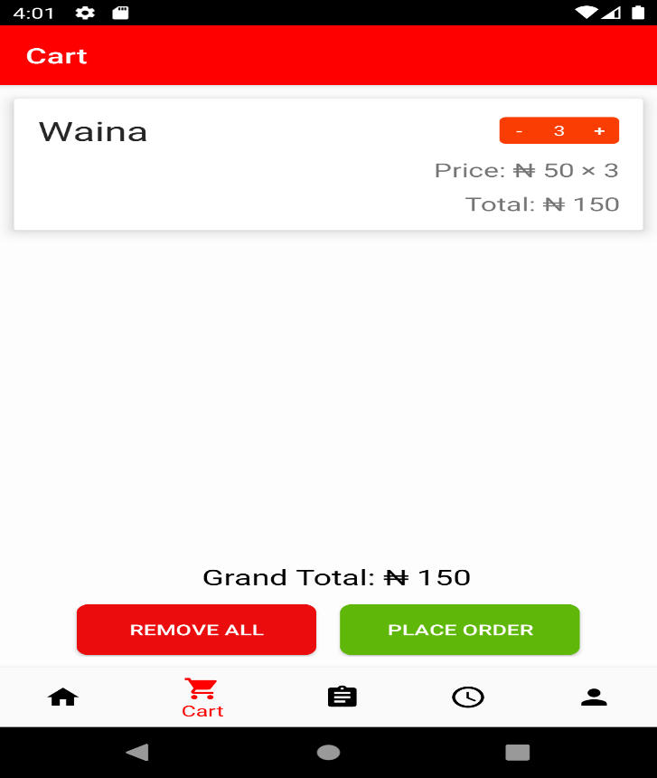

Fig.4.9 Cart

**CUSTOMER PROFILE**

This interface allow the customer to register, edit its information and to log out from the application.

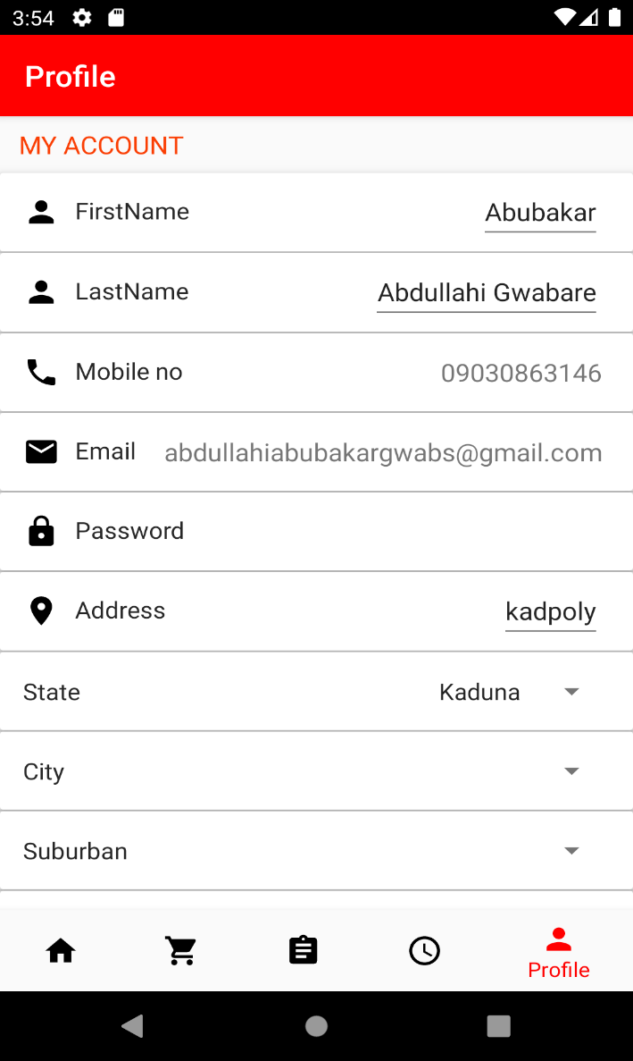

Fig. 4.10 customer profile

**CHAPTER FIVE**

**SUMMARY, CONCLUSION AND RECOMMENDATIONS**

**5.1 SUMMARY**

At the end of this project work, I was able to design and developed an android application that can successfully handle online confectionery ordering for Kaduna polytechnic. In the process of the design, first hand information on confectionery businesses was obtained. This work also will serve as a stepping-stone for people who wish to research more on this topic. Other benefit is the installed software, product ordering and delivery was made easier. The systematic approaches used during each phase of the software development provides a clear road map that would be of immense help to anyone carrying out research work in this area.

**5.2 CONCLUSION**

The development of online confectionery ordering system involved many phases. The approach used is a top-down one concentrating on *what* first, then *how* and moving to successive levels of details.

The first phase started with a detailed study of the problems and prospects of ordering in Kaduna polytechnic. In the course of this study, many problems were discovered to have hindered the effectiveness of the existing manual system. These problems, information needs and activities were documented and later used as the basis for system design, which immediately followed the first phase. The design phase was concerned primarily with the specification of the system elements in manner that best met the organization’s business needs.

During this phase, strict adherence was made on proven software engineering principles and practices. To implement this design, a computer program was then written and tested in android studio environment.

It is hoped that effective implementation of this software product would eliminate many problems discovered during systems investigation.

**5.3 RECOMMENDATIONS**

It is known that for any meaningful android application to be integrated into any organization, proper training and orientation has to be given both to the food vendors and customer. Proper training should be given to the data entry staff on how to handle the application especially during backup processes. In particular, electronic storage media are usually sensitive to change in temperature or pressure and as such, data can be lost very easily. The food vendor should also be highlighted on the need and advantage of the system and how it will equally assist them in their various field of work. They should also be informed of the cost of maintaining this new system so that they will handle it with all carefulness. Training materials should not be presented in formal way but with procedures like policies and forum etc, they should be circulated to the personnel. This will at the end generate appreciation and needed interest to operate the system.

**REFERENCES**

Adithya , R. et al. (2017). *DOI 10.17148/ijarcce.2021.10616 a framework for ...* ONLINE FOOD ORDERING APPLICATION. Retrieved February 20, 2022, from https://www.researchgate.net/publication/352980910_A_Framework_for_Prefetching_of_Social_Media_Content_for_Analysing_Twitter_Data/fulltext/60e1d2e0a6fdccb745045cb0/A-Framework-for-Prefetching-of-Social-Media-Content-for-Analysing-Twitter-Data.pdf.

H. Sethu & Bhavya S.(2016)*Best Online Food Ordering System. Restaurant Checklist.*

Hong L.. (2016). *Online Fast Food Restaurant Ordering Systems*.

Jyotishman D. (2018). *Restaurant Customer Ordering.*

Leong W. (2016). *An introduction to payment gateways: How they can help your business*. Credit Card Processing & Merchant Services - Allied Wallet. Retrieved February 20, 2022, from https://www.alliedwallet.com/blog/blog-posts/an-introduction-to-payment-gateways-how-they-can-help-your-business

Mane, P. J. (2019). *Study of Online Food Delivery App like Zomato & Swiggy and their effect on Casual Dining*. International. Retrieved February 20, 2022, from <https://www.researchgate.net/publication/352980910_A_Framework_for_Prefetching_of_Social_Media_Content_for_Analysing_Twitter_Data/fulltext/60e1d2e0a6fdccb745045cb0/A-Framework-for-Prefetching-of-Social-Media-Content-for-Analysing-Twitter-Data.pdf>.

Mitali Gupta (2019). Online food ordering management system. *International Journal for Research in Applied Science and Engineering Technology*, *9*(VII), 2096–2107. https://doi.org/10.22214/ijraset.2021.36835

Priyanka R. (2013). *Wireless Application for Ordering Management System in a Restaurant.*

Sinuraya, F., & Sihombing, V. (2020). Web-based food ordering information system studi KASUS Rumah Makan aldi. *INFORMATIKA*, *9*(1), 7–11. https://doi.org/10.36987/informatika.v9i1.1938

Shweta F. et al. (2013). *How Online Food Ordering System helps you run more efficiently.*

T.Deepa et al. (2018). *A crispy, salty, American history of Fast Food*. Smithsonian.com. Retrieved February 20, 2022, frohttps://www.smithsonianmag.com/history/crispy-salty-american-history-fast-food-180972459/

APPENDIX

package com.food_on.app;  
  
public class Chef {  
  
 private String Area,City, ConfirmPassword,EmailID,Fname,House,Lname,Mobile,Password,Postcode, State,Suburban;  
  
 public Chef(String Area, String city, String confirmPassword, String emailID, String fname, String house, String lname, String mobile, String password, String postcode, String state, String suburban) {  
 this.Area = Area;  
 City = city;  
 ConfirmPassword = confirmPassword;  
 EmailID = emailID;  
 Fname = fname;  
 House = house;  
 Lname = lname;  
 Mobile = mobile;  
 Password = password;  
 Postcode = postcode;  
 State = state;  
 Suburban = suburban;  
 }  
  
 public Chef() {  
 }  
  
 public String getArea() {  
 return Area;  
 }  
  
 public String getCity() {  
 return City;  
 }  
  
 public String getConfirmPassword() {  
 return ConfirmPassword;  
 }  
  
 public String getEmailID() {  
 return EmailID;  
 }  
  
 public String getFname() {  
 return Fname;  
 }  
  
 public String getHouse() {  
 return House;  
 }  
  
 public String getLname() {  
 return Lname;  
 }  
  
 public String getMobile() {  
 return Mobile;  
 }  
  
 public String getPassword() {  
 return Password;  
 }  
  
 public String getPostcode() {  
 return Postcode;  
 }  
  
 public String getState() {  
 return State;  
 }  
  
 public String getSuburban() {  
 return Suburban;  
 }  
}

package com.food_on.app;  
  
public class Customer {  
  
  
 private String City,ConfirmPassword,EmailID,FirstName,LastName,Mobileno,Password,State,Suburban,LocalAddress;

public Customer() {  
  
  
 }  
  
 public Customer(String City, String confirmPassword, String emailID, String firstName,String lastName, String mobileno, String password, String state, String suburban,String localAddress) {  
 this.City = City;  
 ConfirmPassword=confirmPassword;  
 EmailID = emailID;  
 FirstName=firstName;  
 LastName=lastName;  
 Mobileno = mobileno;  
 Password = password;  
 State = state;  
 Suburban = suburban;  
 LocalAddress=localAddress;  
 }  
  
 public String getCity() {  
 return City;  
 }  
  
 public void setCity(String city) {  
 City = city;  
 }  
  
 public String getConfirmPassword() {  
 return ConfirmPassword;  
 }  
  
 public void setConfirmPassword(String confirmPassword) {  
 ConfirmPassword = confirmPassword;  
 }  
  
 public String getEmailID() {  
 return EmailID;  
 }  
  
 public void setEmailID(String emailID) {  
 EmailID = emailID;  
 }  
  
 public String getFirstName() {  
 return FirstName;  
 }  
  
 public void setFirstName(String firstName) {  
 FirstName = firstName;  
 }  
  
 public String getLastName() {  
 return LastName;  
 }  
  
 public void setLastName(String lastName) {  
 LastName = lastName;  
 }  
  
 public String getMobileno() {  
 return Mobileno;  
 }  
  
 public void setMobileno(String mobileno) {  
 Mobileno = mobileno;  
 }  
  
 public String getPassword() {  
 return Password;  
 }  
  
 public void setPassword(String password) {  
 Password = password;  
 }  
 public String getState() {  
 return State;  
 }  
  
 public void setState(String state) {  
 State = state;  
 }  
  
 public String getSuburban() {  
 return Suburban;  
 }  
  
 public void setSuburban(String suburban) {  
 Suburban = suburban;  
 }  
  
 public String getLocalAddress() {  
 return LocalAddress;  
 }  
  
 public void setLocalAddress(String localAddress) {  
 LocalAddress = localAddress;  
 }  
}

package com.food_on.app;  
  
import androidx.annotation.NonNull;  
import androidx.appcompat.app.AppCompatActivity;  
import androidx.fragment.app.Fragment;  
  
import android.os.Bundle;  
import android.view.MenuItem;  
  
import com.food_on.app.DeliveryFoodPanel.DeliveryPendingOrderFragment;  
import com.food_on.app.DeliveryFoodPanel.DeliveryShipOrderFragment;  
  
import com.food_on.app.R;  
import com.food_on.app.SendNotification.Token;  
  
import com.food_on.app.DeliveryFoodPanel.DeliveryPendingOrderFragment;  
import com.food_on.app.DeliveryFoodPanel.DeliveryShipOrderFragment;  
import com.food_on.app.SendNotification.Token;  
import com.google.android.material.bottomnavigation.BottomNavigationView;  
import com.google.firebase.auth.FirebaseAuth;  
import com.google.firebase.auth.FirebaseUser;  
import com.google.firebase.database.FirebaseDatabase;  
import com.google.firebase.iid.FirebaseInstanceId;  
  
public class Delivery_FoodPanelBottomNavigation extends AppCompatActivity implements BottomNavigationView.OnNavigationItemSelectedListener {  
  
 @Override  
 protected void onCreate(Bundle savedInstanceState) {  
 super.onCreate(savedInstanceState);  
 setContentView(R.layout.*activity_delivery__food_panel_bottom_navigation*);  
 BottomNavigationView navigationView = findViewById(R.id.*delivery_bottom_navigation*);  
 navigationView.setOnNavigationItemSelectedListener(this);  
 UpdateToken();  
 String name = getIntent().getStringExtra("PAGE");  
 if (name != null) {  
 if (name.equalsIgnoreCase("DeliveryOrderpage"))  
 {  
 loaddeliveryfragment(new DeliveryPendingOrderFragment());  
 }  
  
 } else {  
 loaddeliveryfragment(new DeliveryPendingOrderFragment());  
 }  
  
 }  
  
 private void UpdateToken() {  
  
 FirebaseUser firebaseUser = FirebaseAuth.*getInstance*().getCurrentUser();  
 String refreshToken = FirebaseInstanceId.*getInstance*().getToken();  
 Token token = new Token(refreshToken);  
 FirebaseDatabase.*getInstance*().getReference("Tokens").child(FirebaseAuth.*getInstance*().getCurrentUser().getUid()).setValue(token);  
 }  
  
 private boolean loaddeliveryfragment(Fragment fragment) {  
 if (fragment != null) {  
 getSupportFragmentManager().beginTransaction().replace(R.id.fragment_container, fragment).commit();  
 return true;  
 }  
  
 return false;  
 }  
  
 @Override  
 public boolean onNavigationItemSelected(@NonNull MenuItem menuItem) {  
 Fragment fragment = null;  
 switch (menuItem.getItemId()) {  
 case R.id.pendingorders:  
 fragment = new DeliveryPendingOrderFragment();  
 break;  
  
 case R.id.shiporders:  
 fragment = new DeliveryShipOrderFragment();  
 break;  
  
 }  
 return loaddeliveryfragment(fragment);  
 }  
}

package com.food_on.app;  
  
import androidx.appcompat.app.AppCompatActivity;  
  
import android.content.Intent;  
import android.os.Bundle;  
import android.view.View;  
import android.view.animation.Animation;  
import android.view.animation.AnimationUtils;  
import android.widget.Button;  
import android.widget.ImageView;  
  
import com.food_on.app.R;  
public class MainMenu extends AppCompatActivity {  
  
 Button signinemail, signinphone, signup;  
 ImageView bgimage;  
  
  
 @Override  
 protected void onCreate(Bundle savedInstanceState) {  
 super.onCreate(savedInstanceState);  
 setContentView(R.layout.*activity_main_menu*);  
 final Animation zoomin = AnimationUtils.*loadAnimation*(this, R.anim.*zoomin*);  
 final Animation zoomout = AnimationUtils.*loadAnimation*(this, R.anim.*zoomout*);  
 bgimage = findViewById(R.id.*back2*);  
 bgimage.setAnimation(zoomin);  
 bgimage.setAnimation(zoomout);  
  
 zoomout.setAnimationListener(new Animation.AnimationListener() {  
 @Override  
 public void onAnimationStart(Animation animation) {  
  
 }  
  
 @Override  
 public void onAnimationEnd(Animation animation) {  
 bgimage.startAnimation(zoomin);  
 }  
  
 @Override  
 public void onAnimationRepeat(Animation animation) {  
  
 }  
 });  
 zoomin.setAnimationListener(new Animation.AnimationListener() {  
 @Override  
 public void onAnimationStart(Animation animation) {  
  
 }  
  
 @Override  
 public void onAnimationEnd(Animation animation) {  
 bgimage.startAnimation(zoomout);  
 }  
  
 @Override  
 public void onAnimationRepeat(Animation animation) {  
  
 }  
 });  
 signinemail = (Button) findViewById(R.id.*SignwithEmail*);  
 signinphone = (Button) findViewById(R.id.*SignwithPhone*);  
 signup = (Button) findViewById(R.id.*SignUp*);  
  
 signinemail.setOnClickListener(new View.OnClickListener() {  
 @Override  
 public void onClick(View v) {  
  
 Intent signemail = new Intent(MainMenu.this, ChooseOne.class);  
 signemail.putExtra("Home", "Email");  
 startActivity(signemail);  
 finish();  
 }  
 });  
  
 signinphone.setOnClickListener(new View.OnClickListener() {  
 @Override  
 public void onClick(View v) {  
 Intent signphone = new Intent(MainMenu.this, ChooseOne.class);  
 signphone.putExtra("Home", "Phone");  
 startActivity(signphone);  
 finish();  
 }  
 });  
  
 signup.setOnClickListener(new View.OnClickListener() {  
 @Override  
 public void onClick(View v) {  
 Intent signup = new Intent(MainMenu.this, ChooseOne.class);  
 signup.putExtra("Home", "SignUp");  
 startActivity(signup);  
 finish();  
 }  
 });  
  
  
 }  
 @Override  
 protected void onDestroy() {  
 super.onDestroy();  
 System.*gc*();  
 }  
}